GRANARD MUNICIPAL DISTRICT

Corporate Affairs,
Aras an Chontae,
LONGFOIRT.

16th May 2018.

To: Each Member of the Granard Municipal District.

A Chomhairleoir,

You are requested to attend the Annual Meeting of the Granard Municipal District to be held in Granard Community Library on Tuesday, 22nd May 2018 at 3.30 p.m. to transact business, as set out on the Agenda hereunder.

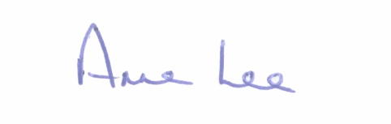
Mise le meas,

_______________
Anne Lee,
Meetings Administrator.

C L A R

1. Re-election of Cathaoirleach.

2. Election of Leas Cathaoirleach .

3. Fix date and time of Granard Municipal District meetings.

